American Spaniel Club

89th Annual Flushing Spaniel Specialty Show and Annual Obedience Trial
January 3-4-5, 2003
Philadelphia, Pennsylvania
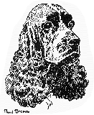

BLACK COCKER SPANIEL

  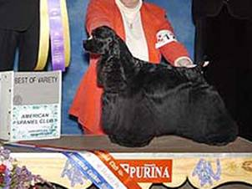
  Best of Variety
  CH. MARKANN'S STACKED DECK
  03.07.1999
  Breeder, K. Ann Jeglum & Jeanne Meister
  By Ch. TLC's No Joke — Ch. TLC's Queen of Hearts. Bitch
  Owner, Dr. K. Ann Jeglum & Karen Kohlmeyer
  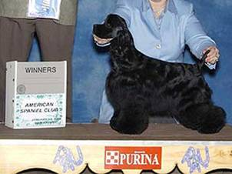
  Best of Winners
  Winners Dog
  KA-RON'S KLASSIFED KASEY
  10.6.2002
  Breeder, Owners
  By Ch. Roadshow-N-Legacy's Obsession — Ch. Ka-Ron's Jessica
  Owner, Kathryn & Ronald Smith

  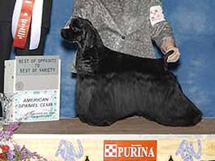
  Best of Opposite Sex
  CH. BLEUMOON'S ILLUSIVE DREAM
  16.04.2000
  Breeder, Michelle Mitchell
  By Ch. Bleumoon's Master of Illusions — Ch. Bleumoon's Time To Dream. Dog
  Owner, Michelle Mitchell & Joan Stallard
  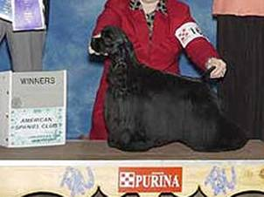
  Winners Bitch
  ANGELICAS A CANDLE LIT NIGHT
  25.07.2001
  Breeder, Randy & Donna Linnemann
  By Ch. Oakmont Prime Time — Oakmont Heavenly Madison
  Owner, Donna Linnemann

  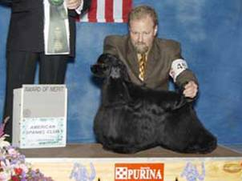
  Award of Merit
  CH. EXL'S THRILL A MINUTE
  17.11.1997
  Breeder, Owners
  By Ch. Ashwood's Thrilling Oppourtunity — Ch. Mistletoe's Mariah. Dog
  Owner, Sandra Knaus & Jan Huml
  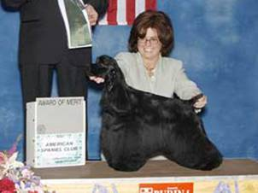
  Award of Merit
  CH. KENARA'S STAND BACK
  26.10.2001
  Breeder, Owners
  By Ch. Bleumoon's Master of Illusions — Ch. Silverhall's Stepping Stone. Bitch
  Owner, Barbara Blum & Joan Stallard

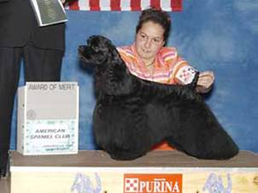
Award of Merit
CH. HARTLINES ABSOLUTLY TRUE
03.06.1998
Breeder, Owner
By Ch. Aftons Absolut — Ch. Hartlines True To You. Dog
Owner, Melinda A. Hart

ASCOB COCKER SPANIEL

  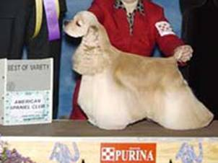
  Best of Variety
  CH. DARKEHAVEN FEAST YOUR EYES
  07.11.1998
  Breeder, Sylvia Fairbanks & Patricia Darke
  By Ch. Darkehaven's Apple of My Eye — Ch. LaBaron's She's A Tease. Dog
  Owner, Patricia Darke & Robert Vaughan & Pamela Maher
  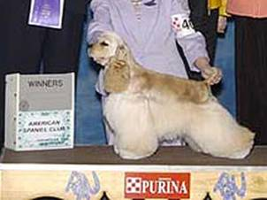
  Best of Winners
  Winners Bitch
  RX SECRETS OF GRIFFINDOR
  11.01.2002
  Breeder, Ernie Domondon
  By Ch.Denali's Christopher Robin — Ch.Sherwood's Black Diamond
  Owner, Lisa Ann Fullington & Erine L. Domondon.

  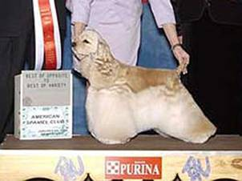
  Best of Opposite Sex
  CH. BEECHWOOD'S STARLIGHT EXPRESS
  15.12.1999
  Breeder, Frank & Cathleen Charest & Victoria Cohen
  By Ch.Jo-Bea's Diamond Trader — Ch.Snowy River Stardust. Bitch
  Owner, Frank & Cathleen Charest.
  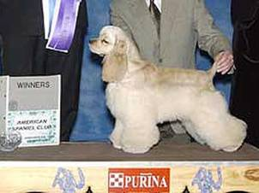
  Winners Dog
  KEBEC'S CALIFORNIAN TRADER
  18.04.2002
  Breeder, Owners
  By Ch. Jo-Bea's Diamond Trader — Larmaro's Kebecs Cancan Dancer
  Owner, Pierre Talbot & Jean A. Delisle.

  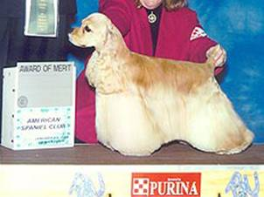
  Award of Merit
  CH. BUTTONWOOD'S CROWN ROYAL
  21.07.1998
  Breeder, Catherine L. Carey
  By Ch. Ging's Ronnies Beau — Ch. Buttonwood's Frost Fire. Dog
  Owner, Catherine Lynch Carey
  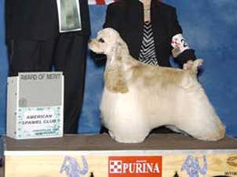
  Award of Merit
  CH. PICABO'S TUFF ACT TO FOLLOW
  22.04.2001
  Breeder, Owner
  By Ch. Micadee's Caught In The Act — Ch. Kimbar's Keepsake. Dog
  Owner, Georgene Jorgensen

  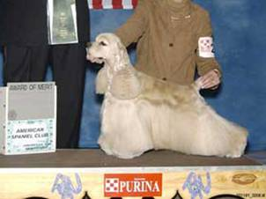
  Award of Merit
  CH. LAURIBEL'S RAINBOW IN SNOW
  22.12.1998
  Breeder, Owner
  By Ch.Encore's Draft Dodger — Ch. Lauribel's Topaz Tassette. Dog
  Owner, Belle Lewis
  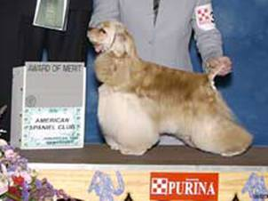
  Award of Merit
  CH. TRINITY'S SPECIAL DELIVERY
  02.12.2000
  Breeder, Owner
  By Ch. Micadee's Caught In The Act — Ch. Trinity's Amaze of Grace. Bitch
  Owner, Susan M. Gray

PARTI COCKER SPANIEL

  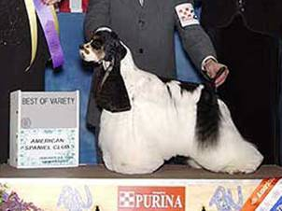
  Best of Variety
  CH. SAN JO'S BORN TO WIN
  27.10.2001
  Breeder, Owner
  By Ch. My-Ida-Ho Look N'Good — Ch. San Jo's Playin To Win. Dog
  Owner, Sandra Bell
  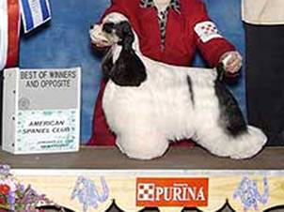
  Best of Winners
  Best of Opposite Sex
  Winners Bitch
  BOW-K'S SIT'N PRETTY
  05.02.2002
  Breeder: Lisa Kay Bowers
  By Ch. My-Ida-Ho Look N Gorgeous-Ch. My-Ida-Ho Look'n For Trouble
  Owner: Sandra Bell & Lisa Kay Bowers

  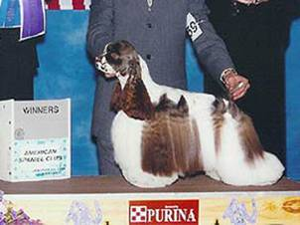
  Winners Dog
  CUMLAUDE GET SMART
  17.10.2001
  Breeder, Owners
  By Ch. Begay's Double Fantasy - Ch. Legend Cumlaude Mocha Latte
  Owner, Drs. Charles & Barbara Lippincott
  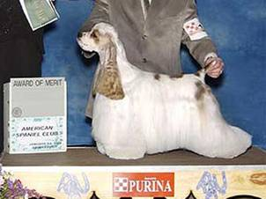
  Award of Merit
  CH. ROCN K'S MI DOLCE DONO
  04.03.2001
  Breeder, Owners
  By Ch. Nosowea's Never Strike Out — Ch.Dunmoor N Rocn K's Mysdefyn. Dog
  Owner, Kim Williams & Tracy Martin.

  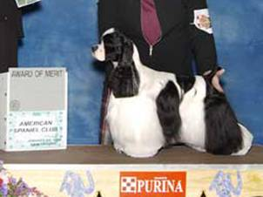
  Award of Merit
  CH. CLOVERCREEK'S DREAM BELIEVER
  02.05.2000
  Breeder, Tonya Higdon & Linda Donaldson
  By Ch. Rendition Triple Play — Ch. Dalin's Desdemona. Bitch
  Owner, Tonya M. Higdon
  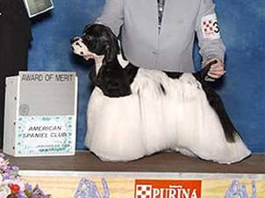
  Award of Merit
  CH. CLOVERCREEK'S MARK OF A DREAM
  02.05.2000
  Breeder, Tonya Higdon & Linda Donaldson
  By Ch. Rendition Triple Play — Ch.Dalin's Desdemona. Dog
  Owner, Tonya & David Higdon

FUTURITY

  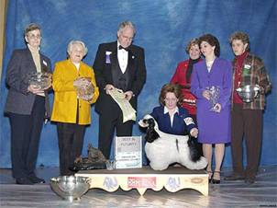
  Best in Futuristy
  BOW-K'S SIT'N PRETTY
  05.02.2002
  Breeder, Lisa Kay Bowers
  By Ch. Mi-Ida-Ho Look N' Gorgeous — Ch. Mi-Ida-Ho Look'n For Trouble
  Owner, Sandra Bell & Lisa Kay Bowers
  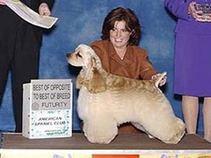
  Best of Opposite Sex to Best in Futurity
  Best in Futurity ASCOB:
  L.A-LAW'S JUST BEAT IT
  03.03.2002
  Breeder, Annalisa Arnett
  By Ch. Gallant's The Beat Goes On — Ch. LA-Law's Trumpet Up Charges
  Owner, Annalisa Arnett & Nancy Gallant

  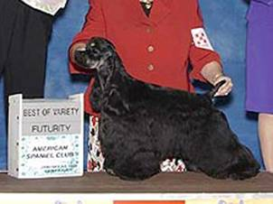
  Best Black in Futurity
  BLEUMOON'S TIME TRAVELER
  02.01.2002
  Breeder, Owner. By Ch. Bleumoon's Just One Time — Ch. Bleumoon's Truly Madly Deeply
  Owner, Michelle Mitchell
  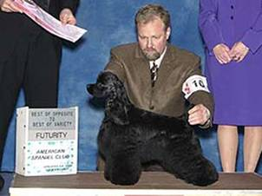
  Best of Opposite Sex to Best Black in Futurity
  HARTLINE I KEN ELS CANDLE N THE WIND
  05.06.2002
  Breeder, Melinda Hart
  By Ch. Hartlines Absolutey True — Ch. I-Ken-Els My Huckleberry Friend. Owner, Sharon Reagan & Melinda Hart

  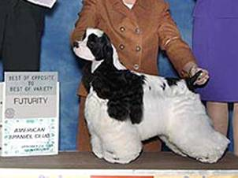
  Best of Opposite Sex to Best Parti-color in Futurity
  SHOWCASES CAPTAIN KIDD
  03.01.2002
  Breeder, Rebecca Rapoport
  By Ch. Alamara's Showcase Treasure — Ch. Showcase's Simply Stunning
  Owner, Janice Pearson.
  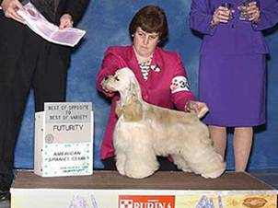
  Best of Opposite Sex to Best ASCOB in Futurity
  CHARLOT'S MAYAN GOLD
  23.04.2002
  Breeder, Charlotte M. Kirton
  By Ch. Lamar's Montana — Ch. Never Blue Gold Dust
  Owner, Cheryl L. Brown.

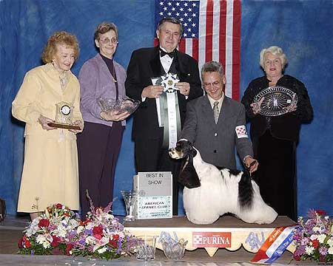
Best in Show
CH. SAN JO'S BORN TO WIN
Breeder, Owner. By Ch. My-Ida-Ho Look N'Good — Ch. San Jo's Playin To Win. Dog.
Owner, Sandra Bell

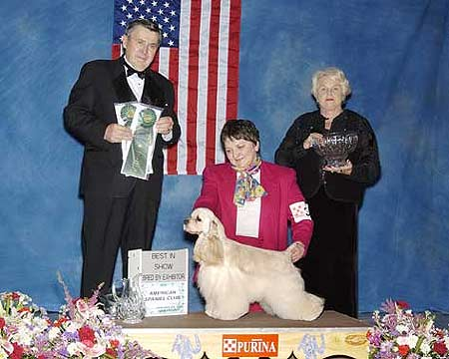
Best in Bred-by-Exhibitor Classes
GAZON TRUE CONFESSIONS
Breeder, Owner. By Ch. Gazon Star Image — Ch. Gazon True Colors.
Owner, Marcia P. Joslyn
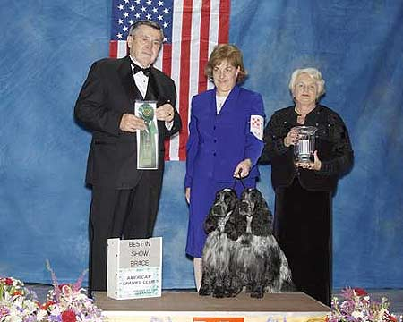
Best Brace in Show
CH. CASCADE’S BOLD N’CAREFREE & CH. CASCADE’S BOLD RULER
Owner: Patricia L. Ferris

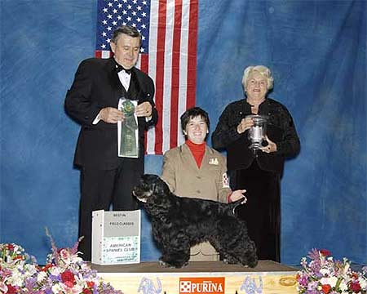
Best In Field Classes
CH. SKYROCKET'S UPLAND SPECIAL, AX, AXJ
Breeder, Owner. By Ch. Kaplar's Prince of Tides — Madison's Black Lace, MH. Dog.
Owner, Melissa S. Frye

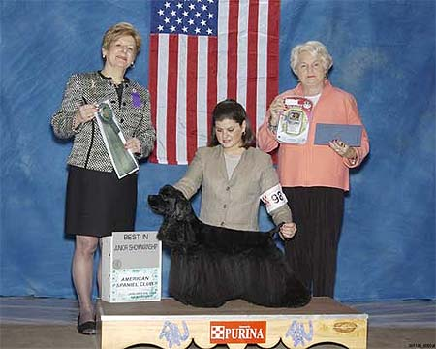
Best in Junior Showmanship
CH. SWEETHEART'S SPACE JAM
Breeder, Maureen Russo
By Ch. Jawat's Latin Lover — Ch. Sweetheart Pretty Women Black. Dog
Owner, Shelby Roberts & Wayne Bottorff

Top Winners

Results for 2003

As of May 31, 2003

 | COCKER SPANIEL ASCOB | Points
1 | 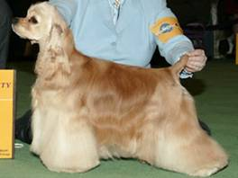  CH Glen Royal's Celtic Dancer  Date of Birth: 23.11.2000  Breeder: Karen B Knight.  Sire: Ch Overoaks Rising Son  Dam: Ch Glen Royal's Still Meadow  Sex: Bitch  Owner: Karen B Knight & Beth Franzen | 2983
2 | CH Darkehaven's Feast Your Eyes  Date of Birth: 07.11.1998  Breeder: S Fairbanks & P Darke  Sire: Ch Darkehaven's Apple Of My Eye  Dam: Ch La Baron's She's A Tease  Sex: Dog  Owner: Patricia Darke & Robert Vaughan & Pamela Maher.  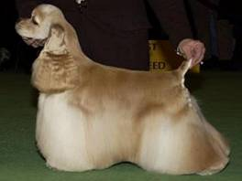 | 2192
3 | CH Shaman's Proud To B Brown  Date of Birth: 20.10.2000  Breeder: Owners  Sire: Ch Sharosa's Roadshow Special T  Dam: Ch Tumbleweed's Cheyenne Vision  Sex: Dog  Owner: Jim Fehring & Debbie Fehring. | 1167
4 | CH Buttonwood's Crown Royal  Date of Birth: 21.7.1998  Breeder: Catherine Lynch Carey  Sire: Ch Ging's Ronnie's Beau  Dam: Ch Buttonwood's Frost Fire  Sex: Dog  Owner: Catherine Lynch Carey.  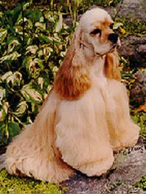 | 1021
5 | CH Picabo's Opening Act  Date of Birth: 22.04.2001  Breeder: Georgene Jorgenson  Sire: Ch Micadee's Caught In The Act  Dam: Ch Kimbar's Keepsake  Sex: Dog  Owner: Georgene Jorgenson | 892
6 | CH Shadowcast N'Mcbrides Design  Date of Birth: 23.07.2001  Breeder: Penny Dante & Rhonda L. Mink  Sire: CH Sherwood Alphabet Soup  Dam: Royalist All American Girl  Sex: Dog  Owner: Tori McBride and Rhonda L. Mink | 759
7 | CH. Daytrippers Freedom Forever  Date of Birth: 12.06.2001  Breeder: Laura Guerrini & Linda Robinson  Sire: Ch Darkehaven's Knock Three Times  Dam: Ch Carell's Winter Sunrise  Sex: Dog  Owner: Laura Guerrini & Linda Robinson.  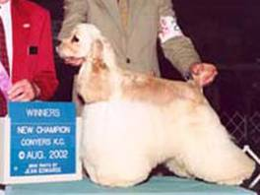 | 532
8 | CH Beechwood's Starlight Express  Date of Birth: 15.12.1999  Breeder:Cathleen & Frank Charest & Victoria Cohen  Sire:Ch Jo-Bea's Diamond Trader  Dam:Ch Snowy River Stardust  Sex:Bitch.  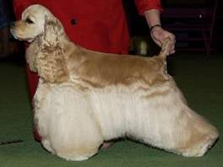 | 426
9 | CH Kim-Marden's Goldenrod | 330
10 | CH Roadshow's Commanding Touch | 301

 | COCKER SPANIEL BLACK | Points
1 | CH Exl's Thrill A Minute  Date of Birth: 17.11.1997  Breeder: Owner  Sire: Ch Ashwood's Thrilling Oportunity  Dam: Ch Mistletoe's Mariah  Sex: Dog  Owner: Sandy Knaus & Jan Huml.  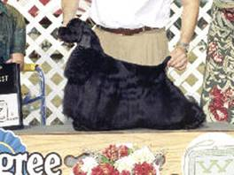 | 5401
2 | CH Bracon's Dancing Girl  Date of Birth: 06.09.2000  Breeder: Heather Sullivan  Sire: Ch Oakmont Prime Time  Dam: Ch Budkens Saloon Singer  Sex: Bitch  Owner: Heather Sullivan | 2521
3 | CH Bleumoon's Illusive Dream  Date of Birth: 16.04.2000  Breeder: Michelle Mitchell  Sire: Ch Bleumoon's Master Of Illusions  Dam: Ch Bleumoon's Time To Dream  Sex: Dog  Owner: Michelle Konverse  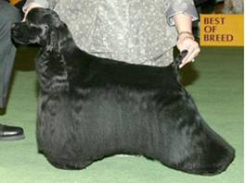 | 1938
4 | CH Half Acres Fosse Of Ketha  Date of Birth: 06.08.2000  Breeder: Hilda Stollenwerk & Tracy Lynn Carroll  Sire: Ch Bleumoon's Master Of Illusions  Dam: Ch TLC'N K's Guilty As Sin  Sex: Dog  Owner: Jerry L Moon & Hans F Reitze  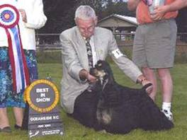 | 1909
5 | CH Markann's Stacked Deck  Date of Birth: 03.07.1999  Breeder: K Ann Jeglum VMD & Jeanne E Mister  Sire: Ch TLC's No Joke  Dam: Ch TLC's Queen Of Hearts  Sex: Bitch  Owner: Dr K Ann Jeglum & Karen L Kohlmeyer.  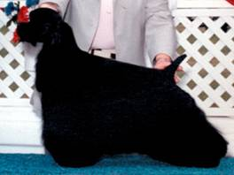 | 1833
6 | CH Stoneridge Thrill Of A Lifetime | 986
7 | CH Tallylyn Robroy On Th' Rocks  Date of Birth: 28.10.1999  Breeder: Larry & Wendy Ohleyer  Sire: Ch. Forjay's Soul Sensation  Dam: Thara's Cheyanne  Sex:  Owner: Barbara B. Bush | 730
8 | CH Mei-Hardt's It's All About Grace  Date of Birth: 09.08.2001  Breeder: Jeanne E. Meister & Tracey L. Carroll  Sire: Ch TLC-NK's King of Hearts  Dam: Ch Mei-Hardt's Solitare  Sex: Bitch  Owner: Pamela Thompson and Jeanne G. Meister | 683
9 | CH Angelicas A Candle Lit Night  Date of Birth: 25.07.2001  Breeder: Randy D Linnemann & Donna P Linnemann  Sire: Ch Oakmont Prime Time  Dam: Oakmont Heavenly Madison  Sex: Bitch  Owner: Donna P Linnemann | 648
10 | CH Lehi's Rocky Mountain High  Date of Birth: 10.01.1998  Breeder: Heidi Armour & Esther Kostlnik  Sire: Ch Cin-Dee's Laurent's Grand Slam  Dam: Oakmont N' Lehi's Summer Knight  Sex: Dog  Owner: Heidi Armour. | 604

 | COCKER SPANIEL PARTI | Points
1 | CH San Jo's Born To Win  Date of Birth: 27.10.2001  Breeder: Sandra Bell  Sire: Ch My-Ida-Ho Look N'Good  Dam: Ch San Jo's Playin To Win  Sex: Dog  Owner: Sandra Bell.  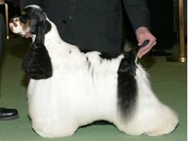 | 8294
2 | 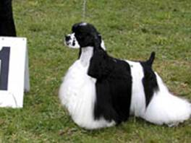  CH V.C.'s House Call  Date of Birth: 14.09.1999  Breeder: Deborah Gunkle & Kim B Vavolo  Sire: Ch Feinlyne Argo  Dam: Ch Longshot's Personality Plus  Sex: Dog  Owner: Deborah Gunkle & Kim B Vavolo | 1879
3 | CH Clovercreek's Mark Of A Dream  Date of Birth: 02.05.2000  Breeder: Tonya M Higdon & Linda Donaldson  Sire: Ch Rendition Triple Play  Dam: Ch Dalin's Desdemona  Sex: Dog  Owner: Tonya & David Higdon. | 1312
4 | 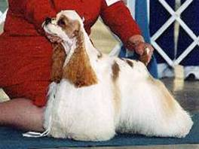  CH Showcase Get On Board  Date of Birth: 02.05.2000  Breeder: Tonya M Higdon & Linda Donaldson  Sire: Ch Rendition Triple Play  Dam: Ch Dalin's Desdemona  Sex: Dog  Owner: Tonya & David Higdon | 1075
5 | CH Misty Hollow's Nacho Supreme  Date of Birth: 08.01.2000  Breeder: Teresa L Voss  Sire: Ch Tri-Pod's Driving Me Buggy  Dam: Ch Misty Hollows Gotta Have It  Sex: Dog  Owner: Angie Voss & Teresa L Voss. | 459
6 | CH Britnatlin's Goodnight Moon  Date of Birth: 13.05.2001  Breeder: Sheila S Schwartz & Irma Rae Mason  Sire: Ch Feinlyne Argo  Dam: Ch Tomara's Spotty Came Home  Sex: Bitch  Owner: Sheila & Ron Schwartz | 402
7 | CH Bow-K's Mad About You | 329
8 | CH Nickleodeon Livin La Vida Loca  Date of Birth: 20.12.2000  Breeder: Kay Nickle & Kathy Fullerton  Sire: Nickleodeon's Devil May Dare  Dam: Mapleayr's Nickleodeon  Sex: Dog  Owner: Pat & Alfons Konrad & Kay Nickle.  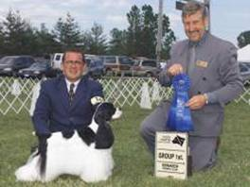 | 321
9 | 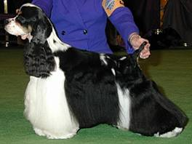  CH Jo-Bea's Hob Nobbin  Date of Birth: 06.05.1996  Breeder: Henry Jones & Bea Jones  Sire: Ch Petticoats Ironwill  Dam: Ch Irresistible Heart's Desire  Sex: Dog  Owner: Robert & Rita Lewis | 274
10 | CH Kindred Etoile De Diamant  Date of Birth: 29.09.2001  Breeder: Owner  Sire: Ch Luzana's Le'Toile Dujour  Dam: Duet Diamond Double  Sex: Bitch  Owner: Bobbie Kolehouse | 259

